**NAME: PAVITHRA PILLAI**

**CLASS: MSc. PART - II**

**COURSE: BIOINFORMATICS**

**ACADEMIC YEAR: 2022-2023**

**ROLL NO: 120**

**PAPER CODE: GNKPSBIP304**

**COURSE TITLE: INTRODUCTION TO PERL AND MONGODB**

**GURU NANAK KHALSA COLLEGE**

**MATUNGA, MUMBAI-400 019.**

**DEPARTMENT OF BIOINFORMATICS**

**CERTIFICATE**

This is to certify that **Ms. Pavithra Pillai (Roll No. 120)** of M.Sc. Part II Bioinformatics has satisfactorily completed the practical Semester II course prescribed by the University of Mumbai during the academic year 2022-2023.

# TEACHER INCHARGE HEAD OF DEPARTMENT

**INDEX:**

|  |  |  |  |  |
| --- | --- | --- | --- | --- |
| **SR.NO.** | **EXPERIMENTS** | **PAGE**  **NO.** | **DATE** | **SIGN** |
| 1. | Simple programs on Variable types used in Perl |  | 09/07/22 |  |
| 2. | Conditional statements and Loops |  | 09/07/22 |  |
| 3. | Operators used on scalar, array and hash variables |  | 20/07/22 |  |
| 4. | Subroutine |  | 01/08/22 |  |
| 5. | References and Dereferences, and Scope of variables |  | 01/08/22 |  |
| 6. | Regular Expressions |  | 17/08/22 |  |
| 7. | Metacharacters, Quantifiers and Substrings |  |  |  |
| 8. | Perl Formatting |  |  |  |

**Practical 1**

**Simple Programs on Variable types using Perl Aim**: To understand and write simple Perl programs on variable and data types **Theory**:

* Created by Larry Wall in 1987, Perl is a general-purpose programming language originally developed for text manipulation and now used for a wide range of tasks including system administration, web development, network programming, GUI development and more.
* Pros:
  + Good for Quick and complex scripts
  + Parsing & restructuring data
  + High level programming, Networking, Graphical, Database
* Cons:
  + Hardware Drivers
  + Many modules are incomplete
* Basics:
  + Statement must end in ;
  + Comment is #
  + Multiline comment:

▪ =begin

▪ =cut

* + Naming Scheme is .pl
  + The Perl interpreter ignores whitespaces
  + Single quote [‘’] the statement in printed as is
  + Double quote [“”] the statement operators are executed
* Data types / Variable types
  + Perl has 3 Basic Data types
  + Scalar: Scalars are simple variables. They are preceded by a dollar sign ($). A scalar is either a number, a string, or a reference. A reference is actually an address of a variable.
  + Array: Arrays are ordered lists of scalars that you access with a numeric index, which starts with 0. They are preceded by an "at" sign (@).
  + Hash: Hashes are unordered sets of key/value pairs that you access using the keys as subscripts. They are preceded by a percent sign (%).

Q1. Write a Perl Script to store DNA sequence in Scalar variable entered by user and display an output

CODE:

print("Enter your sequence");

$seq= <stdin>;

print("The seq you have entered is: $seq");

print("The seq you have entered is: $seq");

OUTPUT:



Q2. Write a Perl script to ask user to enter RNA sequence using an array without loops

CODE:

@seq;

print ("Enter your first RNA sequence:");

$seq[0]= <stdin>;

print ("Enter your second RNA sequence:");

$seq[1]= <stdin>;

print ("Enter your third RNA sequence:");

$seq[2]= <stdin>;

print ("Enter your fourth RNA sequence:");

$seq[3]= <stdin>;

print ("Enter your fifth RNA sequence:");

$seq[4]= <stdin>;

print("The sequences you entered are: /n");

print("seq 1: $seq[0]");

print("seq 2: $seq[1]");

print("seq 3: $seq[2]");

print("seq 4: $seq[3]");

print("seq 5: $seq[4]");

OUTPUT:

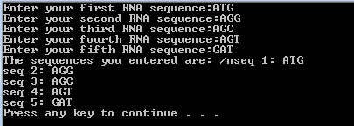

Q3. Write a perl script to store codon using hash varibles

CODE:

%codon= ( 1=>AUG, 2=>AGG, 3=>UAA);

print (%codon);

OUTPUT:



**Practical 2 Conditional Statements and loop**

**Aim**: To understand and write code using conditional statements and loops

# Theory:

* Perl conditional statements helps in the decision making, which require that the programmer specifies one or more conditions to be evaluated or tested by the program
* Along with a statement or statements to be executed if the condition is determined to be true, and optionally, other statements to be executed if the condition is determined to be false.
* Syntax

if(boolean_expression) {

# statement(s) will execute if the given condition is true

}

* A perl statement can be followed by an optional else statement, which execute when the Boolean expression is false
* Syntax

if(boolean_expression) {

# statement(s) will execute if the given condition is true

} else {

# statement(s) will execute if the given condition is false

}

* An if statement can be followed by an optional elsif…else statement, which is very useful to test the

various conditions using single if…elsif statement

if(boolean_expression 1) {

# Executes when the boolean expression 1 is true

} elsif( boolean_expression 2) {

# Executes when the boolean expression 2 is true

} elsif( boolean_expression 3) {

# Executes when the boolean expression 3 is true

} else {

# Executes when the none of the above condition is true

}

* A Perl unless statement consists of a Boolean expression followed by one or more statements

unless(boolean_expression) {

# statement(s) will execute if the given condition is false

}

* The unless statement can then again be followed by an else statement

unless(boolean_expression) {

# statement(s) will execute if the given condition is false

} else {

# statement(s) will execute if the given condition is true

}

* This unless statement can then also be followed by an elsif statement

unless(boolean_expression 1) {

# Executes when the boolean expression 1 is false

} elsif( boolean_expression 2) {

# Executes when the boolean expression 2 is true

} elsif( boolean_expression 3) {

# Executes when the boolean expression 3 is true

} else {

# Executes when the none of the above condition is met

}

* A switch statement allows a variable to be tested for equality against a list of values. Each value is called a case and the variable being switched on is checked fo each switch case

use Switch;

switch(argument) {

case 1 { print "number 1" } case "a" { print "string a" }

case [1..10,42] { print "number in list" } case (\@array) { print "number in list" } case /\w+/ { print "pattern" }

case qr/\w+/ { print "pattern" }

case (\%hash) { print "entry in hash" } case (\&sub) { print "arg to subroutine" } else { print "previous case not true" }

}

* A loop statement allows us to execute a statement or group of statements multiple times
* While loop statement in perl programming language repeatedly executes a target statement as long as a given condition is true

while(condition) { statement(s);

}

* An until loop statement in perl programming language repeatedly executes a target statement as long

as a given condition is false

until(condition) { statement(s);

}

* A for loop is a repetition control structure that allows you to efficiently write a loop that needs to

execute a specific number of times

for ( init; condition; increment ) { statement(s);

}

* The foreach loop iterates over a list value and sets the control variable to be each element of the list

in turn

foreach var (list) {

...

}

* A do…while loop is similar to the while loop except that a do while loop is guaranteed to execute at

least one time

do { statement(s);

}while( condition );

* A loop can be nested inside of another loop, this is known as a nested for loop

for ( init; condition; increment ) { for ( init; condition; increment ) { statement(s);

}

statement(s);

}

Q1. Write a perl script to ask user to enter a number and check whether entering number is even or odd

CODE:

print("Enter a number: ");

$a= <stdin>;

if ($a%2 ==0){

print("The no you have entered is even ");

}

else{

print("The no you have entered is odd ");

}

OUTPUT:





Q2. Write a perl script to ask user to enter number to display Fibonacci series

CODE:

print("How many digits of fibonacci are to be printed: ");

$limit = <stdin>;

$cur_num = 1;

$prev_num = 0; print("$prev_num, $cur_num"); for($i=1; $i<=($limit-2); $i++){

$ans = $cur_num + $prev_num;

$prev_num = $cur_num;

$cur_num = $ans; print("$ans ");

}

OUTPUT:



Q3. Write a Perl script to ask user to enter a number and check where entered number is negative or positive

CODE:

print ("Enter a number: ");

$num= <stdin>;

if ($num > 0){

print ("The no is a positive number: ");

}

else{

print ("The no is a negative number: ");

}

OUTPUT:





Q4. Write a Perl script to ask user to enter RNA sequence using an array with for and for each loops

CODE:

@rna_seq; for($i=0;$i<5;$i++){

print("Enter sequence #$i: ");

$rna_seq[$i] = <stdin>;

}

foreach $seq(@rna_seq){ print("Sequence: $seq");

}

OUTPUT:

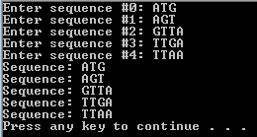

Q5. Write a Perl script to ask user to enter DNA sequence using a hash and display keys and values separately

CODE:

%dna_seq; for($i=0;$i<5;$i++){

$num = $i+1;

print("Enter sequence $num: ");

$dna_seq{$i} = <stdin>;

}

for($i=0; $i<5;$i++){

$num = $i+1;

print("Sequence{$num} = $dna_seq{$i}");

}

OUTPUT:

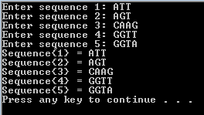

Q6. Write a Perl script to ask user to enter number and find factorial of an entered number

CODE:

print("Enter a number: ");

$number = <stdin>;

$ans = 1; for($i=$number;$i>=1;$i--){

$ans = $i*$ans;

}

print("Factorial of $number is $ans\n");

OUTPUT:

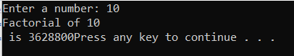

Q7. Write a Perl script to store DNA sequence and check entered sequence is DNA or not

use Switch;

$seq = <stdin>;

$is_DNA = false; for($i=0;$i<length($seq)-1;$i++){

$check = substr($seq, $i, 1);

switch($check){

case "A" case "T" case "G"

case "C"

{$is_DNA = true}

{$is_DNA = true}

{$is_DNA = true}

{$is_DNA = true}

default : print "It is not a DNA Sequence"; exit;

}

}

if($is_DNA == true){

print("It is a DNA sequence");

}

OUTPUT:



Q8. Perl script to display the following pattern A AAAA

A AAA A AA A A

A

CODE:

$num = 5; for($i=0;$i<6;$i++){

for($j=$num;$j>0;$j--){

print("A");

}

print("\n");

$num--;

}

OUTPUT:

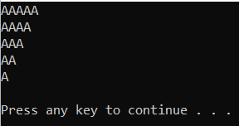

**Practical 3**

**Operators used on scalar, array and hash variables**

**Aim**: To understand and write perl programs for operators used on scalar, array and hash variables

# Theory:

* An operator can be explain by using the expression 4+5 =9 where 4 and 5 are operands and + is the operator
* Perl support many operator types,
  + Arithmetic Operator
  + Logical Operators
  + Equality Operators
  + Miscellaneous Operators
* Arithmetic operators are:

o + Addition (Adds elements)

* + – Subtraction (Subtracts elements)
  + * Multiplication (Multiplies elements)
  + / Division (Divides elements and returns quotient)
  + % Modulus (Divides elements and returns remainder)
  + ** Exponent (Gives exponents of a number up to the number specified)
* Equality operators are:

o == Equal to (Checks if left and right values are equal to each other)

* + ⬄ Comparison (Checks if value are equal or not and returns -1, 0, 1 depending on whether the left value is less than, equal to, grater than the right value
  + > Greater than (Checks if left value is greater than the right value)
  + < Less than (Checks if left value is less than the right value)
  + >= Greater than or equal to (Checks if left value is greater than or equal to the right value)
  + <= Less than or equal to (Checks if left value is less than or equal to the right value)
  + The following operators are used for strings
  + lt : Less than
  + gt : Greater than
  + le : Lass than or equal to
  + ge : Greater than or equal to
  + eq : Equal to
  + ne : Not equal to
  + cmp : Compares and returns values -1, 0, 1 depending on which values Is greater or lesser
* Logical operators are:
  + && (and) : IF both operands are true then the condition becomes true
  + || (or) : If one or the other operand is true then the condition becomes true
  + Not : Used to reverse the condition
* Miscellanous operators are:
  + . dot operator (combines 2 strings)
  + x repeat operator (String on the left is repeated the amount of times specified on the right

o ++ increment operator (Increases the values of the int by 1)

* + – decrement operator (Decreases the values of the int by 1)
  + -> Arrow operator (Used in dereferencing a method or variable from an object or a class name

Q1. Write a Perl script accept two number and a string and perform the following operations

1. Perl Arithmetic Operators
2. Miscellaneous Operators CODE:

print "Enter a number: ";

$a=<stdin>;

print("enter another number: ");

$b=<stdin>;

print "Enter a string: ";

$s1=<stdin>;

print "Enter another string: ";

$s2=<stdin>;

$addition= $a+$b;

print"the addition is $addition \n";

$subtraction= $a-$b;

print"the subtraction is $subtraction \n";

$division= $a/$b;

print"the division is $division \n";

$multiplication= $a*$b;

print"the multiplication is $multiplication \n";

$concat= $s1.$s2;

print"the concatination is $concat";

$rep= $s1 x 3;

print "the rep is $rep \n";

@range= $a .. $b;

print"the range is @range \n";

$increment=$a++;

print"increment is $increment \n";

$decrement=$a--;

print"decrement is $decrement \n";

OUTPUT:

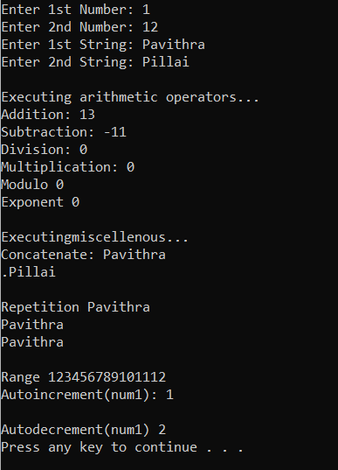

Q2. Write a perl script to accept three number and display smallest number

CODE:

print "Enter a number: ";

$a=<stdin>;

print("Enter second number: ");

$b=<stdin>;

print("Enter third number: ");

$c=<stdin>;

if ($a<$b && $a<$c){

print "the smallest no is $a";

}

elsif ($b<$a && $b<$c){

print "the smallest no is $b";

}

else {

print" the smallest no is $c";

}

OUTPUT:

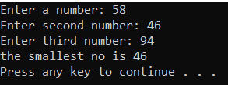

Q3. Write a perl script to enter two string and check whether its equal or not

CODE:

print "Enter a string: ";

$a=<stdin>;

print("Enter second string ");

$b=<stdin>;

if ($a eq $b){

print "It's equal ";

}

else {

print" It's not equal ";

}

OUTPUT:

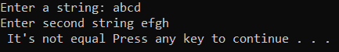 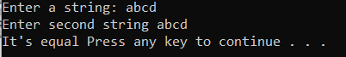

Q4. Write a Perl script to store elements in an array and perform the following

1. Find length of the array
2. Add one element at end of an array
3. Remove one element at beginning of an array
4. Add one element at beginning of an array
5. Remove on element at end of an array

CODE:

@array = (45,6,3,42,35,22,67,54,23);

print("Array is @array\n");

print("\nLength of the array is $#array\n");

print("\nAdding 25 to the end of the array...\n"); push(@array, 25);

print("Array after adding 25 is @array\n");

print("\nRemoving an element from beginning of the array...\n"); shift(@array);

print("Array after removing element from beginning is @array\n");

print("\nAdding 25 to the beginning of the array...\n"); unshift(@array, 25);

print("Array after adding element to beginning is @array\n");

print("\nRemoving an element from end of the array...\n"); pop(@array);

print("Array after removing element from end of array is @array\n");

OUTPUT:

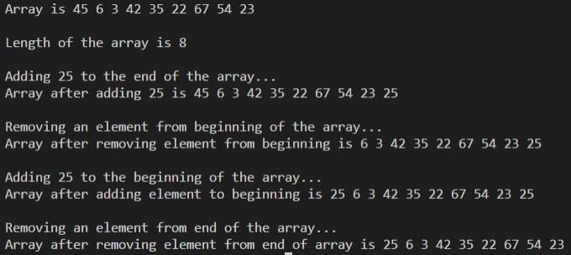

Q5. Write a perl script create elements in an array like ATGCA, ATTG, AATGC, AAAT and perform the following:

1. Find length of an array
2. Add one element i.e., ATGC at bottom of an array
3. Remove one element at beginning of an array
4. Add one element i.e., ATGCC at top of an array
5. Remove one element at end of an array

CODE: @element=("ATGCA","ATTG","AATGC","AAAT");

@seq = qw/ATGCA ATTG AATGC AAAT/;

print "The length of the array is $#element\n";

push(@seq,"ATGC"); #add elem at the end print"\nThe array after adding is

@seq\n";

shift(@seq);

#remove elem from start

print"\nArray after removing one element from start

@seq\n";

unshift(@seq, "ATGCC"); #add elem from start print"\nArray after adding one element from start

@ seq \n";

pop(@seq);

#remove one elem from end

print"\nArray after removing one from start:

@ seq \n";

OUTPUT:

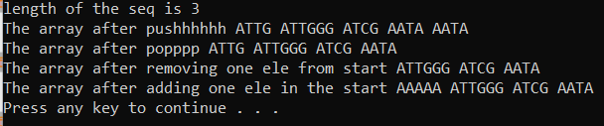

Q6. Write a perl script to create an array and perform following operations such as merge, reverse and sorting

CODE:

@array1= (1,2,3,4,5,7);

@array2= (8,9,11,10,13,12);

@array3= (@array1, @array2);

@chr= qw/a b d s e f g y z/;

print"@array3\n";

@sorted=sort {$a <=> $b} @array3;

print("@sorted\n");

@rev = reverse(@sorted);

print("@rev\n");

OUTPUT:

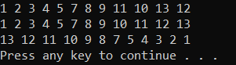

Q7. Display array in descending order:

CODE:

@array1= (1,2,3,4,5,7,8,9,10,11,12);

Print(“@array1\n”);

@sorted=sort {$b <=> $a} @array1; print("@sorted\n");

OUTPUT:

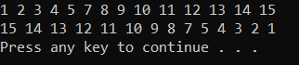

Q8.Write a perl script to store string of an array and display index number 3,4,5 at once

CODE:

@strings = ("ATGU", "ATTG", "ATCG", "TGAC", "TCGA", "TACG", "GCTA");

print(@strings[3..5]);

OUTPUT:



Q9. Write a perl script to demonstrate splice operator

CODE:

@arr = (0..9);

print("Complete array @arr\n");

@replacement = splice(@arr, 3, 5, b..f); print("Added Elements @arr\n");

OUTPUT:

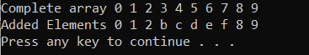

Q10. Write a perl script to sort hashes using keys

CODE:

%data = ('b' => 2, 'a' => 1, 'e' => 5, 'd' => 4, 'c' => 3);

@data_sorted = sort(%data); print(@data_sorted);

OUTPUT:



Q11. Write a Perl program to determine the frequency of nucleotide bases in given nucleotide sequence using nested if else

CODE:

$seq = <stdin>;

$a = 0;

$t = 0;

$g = 0;

$c = 0;

for($i=0; $i<length($seq); $i++){

$n = substr($seq, $i, 1); if($n eq "a"){

$a++;

}elsif($n eq "t"){

$t++;

}elsif($n eq "g"){

$g++;

}elsif($n eq "c"){

$c++;

}

}

print("a was found $a times\n"); print("t was found $t times\n"); print("g was found $g times\n");

print("c was found $c times\n");

OUTPUT:

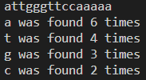

**Practical 4 Subroutines**

**Aim**: To understand and write program for Perl subroutine

# Theory:

* Perl subroutines are functions in which a group of statements that together perform a task
* Code can be divided among various subroutines and each subroutine can perform a specific task which increases the modularity of the code
* The terms subroutine, method and function are used interchangeably in perl
* Subroutine is defined as

sub subroutine_name { body of the subroutine

}

* This subroutine is then called by doing

subroutine_name( list of arguments );

* Arguments can be passed to a subroutine by using the special array @_;
* Arrays hashes can be passed as normal scalar arguments

Q1. Write a perl program to create a subroutine named calculate and find area and perimeter of rectangle

CODE:

sub Calculate{

print("Give length of the rectangle: ");

$len = <stdin>;

print("Give breadth of the rectangle: ");

$bre = <stdin>;

$area = $len * $bre;

$peri = 2*($len + $bre);

print("Area of the rectangle is $area\n"); print("Perimeter of the rectangle is $peri\n");

}

Calculate();

OUTPUT:

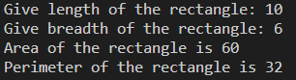

Q2. Write a perl program to create a subroutine named calculate and find area and perimeter of a rectangle with parameters

CODE:

sub Calculate{

my($l, $b) = @_;

$area = $l*$b;

$peri = 2*$l + 2*$b;

print("Area of the Rectangle is $area\n");

print("Perimeter of the Rectangle is $peri\n");

}

print("Enter length of the Rectangle: ");

$l = <stdin>;

print("Enter breadth of the Rectangle: ");

$b = <stdin>;

Calculate($l,$b);

OUTPUT:

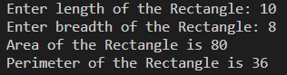

**Practical 5**

**References, dereferences, and scope of variables**

**Aim**: To understand and write perl program for references and dereferences and scope of variables

# Theory:

* References is a scalar datatype that holds the location of another value which could be scalar, array or hash.
* Because of its scalar nature, areference can be used anywhere a scalar can be used
* References are created by

$scalarref = \$foo;

$arrayref = \@ARGV;

$hashref = \%ENV;

$coderef = \&handler;

$globref = \*foo;

* Dereferencing returns the value from a reference point to the location.
* Deferencing is done by simple using $, @ or % prefix of the reference variable depending on whether the reference is pointing to which datatype
* References to functions are done by using the \& signal handler

$cref = \&PrintHash;

&$cref(%hash);

* By default perl using global variables which means the variables can be accessed from anywhere in the program. But you can create a private variable by using the my keyword

sub somefunc {

my $variable; # $variable is invisible outside somefunc()

my ($another, @an_array, %a_hash); # declaring many variables at once

}

* State variables are variables whose values can be changed once they are initialized

state $count = 0;

Q1. Write a perl script to accept a number and create reference of scalar variable and display a value using dereferencing

CODE:

print("Enter a number: ");

$num = <stdin>;

$ref_num = \$num;

print("Number entered and stored in Reference is ",${$ref_num},"\n");

OUTPUT:



Q2. Write a perl script to store an array and use reference and dereference

CODE:

@arr = qw/Biology Zoology Mathematics Physics Chemistry/;

$ref_arr = \@arr;

print("Array entered and stored in Refenrence is ", @{$ref_arr},"\n");

OUTPUT:



Q3. Write a perl script to store a hash and use reference and derefencing

CODE:

%subjects = (1=>"Biology", 2=>"Zoology", 3=>"Mathematics", 4=>"Physics", 5=>"Chemistry");

$ref_hash = \%subjects;

print("Hash entered and stored in Refenrence is ",%{$ref_hash},"\n");

OUTPUT:



Q4. Write a perl script to create a subroutine and use reference and dereferencing

CODE:

sub default{

print("This is a subroutine\n");

}

$sub_ref = \&default;

print("The reference will be called now\n\n"); &{$sub_ref;}

OUTPUT:



Q5. Write a perl script to store number in global variable and demonstrate the scope of it

CODE:

sub g_pr{

$global_num = 70;

print("Printing global variable inside the subroutine it was declared in: $global_num\n");

}

g_pr();

print("Printing global variable outside the subroutine it was declared in: $global_num\n");

OUTPUT:



Q6. Write a perl script to store a number in private variable and demonstrate the scope of it

CODE:

sub pr_var{

my $private_var = 70;

print("Printing Private variable inside the subroutine it was declared in: $private_var\n");

}

pr_var();

print("Priting private variable outside the subroutine it was declared in: $private_var\n");

OUTPUT:



Q7. Write a perl script to store a number in state variable and display an OUTPUT CODE:

use feature 'state';

state $static_number = 70;

print("Printing Static variable $static_number\n");

print("Trying to change value of static variable from 70 to 100\n");

$static_number = "shalmon";

print("Printing Static variable after changing $static_number\n"); OUTPUT:

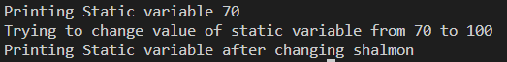

**Practical 6**

**Regular Expression**

**Aim:** To understand concepts revolving around regular expressions and solve problems related to it.

**Theory:**

* A regular expression is a string of characters that defines the pattern or patterns you are viewing.
* Perl syntax for regex is similar to that of other programs that support regex
* Regular expression is applied by using a binding operator “=~” and “!~”.
* There are a total of 3 operators withing regex in perl
  + Match operator : m/PATTERN/MODIFIERS
    - Match operator has modifiers that can be stated at the end of the regex. These modifiers are:
      * i – matches case insensitive
      * m – specifies that if the string has newline or carriage return characters
      * o – Evaluates the expression only one
      * s – allows used of . to match newline character
      * x – Allows use of whitespace in the expression
      * g – globally finds all matches
      * cg – continues search even after global match fails
  + Substitute operator: s/PATTERN/REPLACEMENT/MODIFIERS
    - Substitute operator has almost the same modifiers as the math operator. Those are:
      * i – matches case insensitive
      * m – specifies that if the string has newline or carriage return characters
      * o – Evaluates the expression only one
      * s – allows used of . to match newline character
      * x – Allows use of whitespace in the expression
      * g – globally finds all matches
      * e – Evaluates the replacement as if it were a perl statement and uses it sreturn value as the replacement text
  + Transliterate operator: tr/SEARCHLIST/REPLACEMENT/MODIFIERS
    - Transliterate has the least amount of modifiers
      * c – complements SEARCHLIST
      * d – deletes found but unreplaced characters
      * s – squashes duplicate replaced character

Q1. Write a perl script to accept a DNA sequence and match against pattern “aatg” is found on entered sequence and check whether the match case case insensitive

CODE:

print("Enter DNA sequence: ")

seq = <stdin>;

if($seq =~ m/aatg/i){

print("aatg exists in the entered sequence.\n");

}else{

print("aatg does not exist in the entered sequence");}

OUTPUT:



Q2. Write a perl script to accept DNA sequence from user and search pattern “att” and replace with “agt”

CODE:

print("Enter DNA sequence: ");

$seq = <stdin>;

if($seq =~ m/att/){

$seq =~ s/att/agt/;

print("Sequence has been replaced...\n");

print("New sequence is $seq\n");

}else{

print("att does not exist in sequence");

}

OUTPUT:

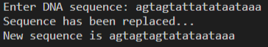

Q3. Write a perl script to accept RNA sequence form user and search pattern “auu” and replace with “agcu” in whose sequence

CODE:

print("Enter RNA sequence: ");

$seq = <stdin>;

if($seq =~ m/auu/){

print("Replacing in sequence.....\n");

$seq =~ s/auu/agcu/g;

print("The new sequence is $seq\n");

}else{

print("The patter 'auu' does not exist in the sequence");

}

OUTPUT:



Q4. Write a perl script to accept RNA sequence and convert that into DNA sequence

CODE:

print("Enter an RNA sequence: ");

$seq = <stdin>;

if($seq =~ m/u/){

print("The entered RNA sequence will now be converted into DNA sequence...\n");

$seq =~ s/u/t/g;

print("The converted sequence is : $seq");

}else{

print("Enter an RNA sequence!!");

}

OUTPUT:

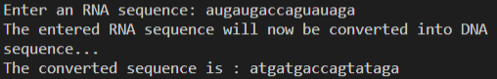

Q5. Write a perl script to accept a string and remove duplicate characters from entered string

CODE:

print("Enter a string: ");

$string = <stdin>;

$string =~ tr/a-z/a-z/s;

print("Entered string without duplicate letters is: $string\n");

OUTPUT:



**Practical 7**

**Metacharacters, Quantifiers and Substring**

**Aim:**

To understand concepts revolving around metacharacters, quantifiers and substring egular expressions and solve problems related to it.

**Theory:**

For all their power and expressivity, patters in perl recognize the same 12 traditional metacharacters found in many other regular expression packages: \ | ( ) [ { & $ * + ? .

Some simple metacharacters stand by themselves, like . and ^ and $ they don’t directly affect anything around them. Some metacharacters work like prefix operators, governing what follows them, like \. Other work like postfix operators, governing what immediately precedes them, like *, +, and ?. One metacharacter, |, acts like an infix operator, standing between the operands it governs. There are even bracketing metacharacters that work like circumfix operators, governing something contained inside them, like (…) and […]. Parentheses are particularly important, because they specify the bounds of | on the inside, and of *, +, and ? on the outside.

If you learn only one of the twelve metacharacters, choose the backslash. That’s because backslash disables the other. When a backslash precedes a nonalphanumeric characters in a perl pattern, it always makes the next character a literal. If you need to match one of the twelve metacharacters in a pattern literally, you wirite them wit a backslash in front. Thus, \, matches a real dot, \$ a real dollar sign, \\ a real backslash, and so on. This known as “escaping” the metacharacter, or “quoting it” or sometimes just “backslashing” it.

**Metacharacters:**

|  |  |
| --- | --- |
| Symbol | Meaning |
| \... | De-meta next nonalphanumeric character, meta next alphanumeric character (maybe) |
| ....|… | Alternation (match one or the other) |
| (…) | Grouping (treat as a unit) |
| […] | Character class (Match one character from a set) |
| ^ | Truw at beginning of string(or after newline, maybe) |
| . | Match one character (Except newline, normally) |
| $ | True at end of string (or before any newline, maybe) |

**Quantifiers:**

|  |  |
| --- | --- |
| Symbol | Meaning |
| * | Match 0 or more time (maximal) |
| + | Match 1or more times (maximal) |
| ? | Match 1 or 0 times (maximal) |
| {COUNT} | Match exactly COUNT times |
| {MIN,} | Match at least MIN times {maximal} |
| {MIN,MAX} | Match at least MIN but not more than MAX times (maximal) |
| *? | Match 0 or more times (minimal) |
| +? | Match 1 or more times (minimal) |
| ?? | Match 0 or 1 time (minimal) |
| {MIN,} | Match at least MIN times (minimal) |
| {MIN, MAX} | Match atleast MIN but not more |

Q1. Write a perl program to check that a string contains only a certain set of characters (in this case a-z, A-Z, 0-9)

Code:

print("Enter a string: ");

$string = <stdin>;

if($string =~ m/\w/){

print("its a match\n");

}else{

print("Its not a match\n");

}

Output:





Q2. Write a perl program that matches a string that has an a followed by zero or more t’s

Code:

print("Enter a sequence: ");

$seq = <stdin>;

if($seq =~ m/at*/){

print("There is an a followed by 0 or more t's\n");

}else{

print("There is not an a followed by 0 or more t's\n");

}

Output:





Q3. Write a perl program that matches a string that has an a followed by one or more b’s

Code:

print("Enter a sequence: ");

$string = <stdin>;

if($string =~ m/ab+/){

print("TRUE\n");

}else{

print("FALSE\n");

}

Output:





Q4. Write a perl program that matches a string that has an ‘a’ followed by anything, ending in ‘b’

Code:

print("Enter a string: ");

$string = <stdin>;

if($string =~ m/a/ && $string =~ m/b$/){

print("TRUE\n");

}else{

print("FALSE\n");

}

Output:





Q5. Write a perl program that matches a word at the beginning of a string

Code:

print("Enter a string that starts with 'Quintessential': ");

$string = <stdin>;

if($string =~ m/^Quintessential/){

print("You followed the order\n");

}else{

print("You did not follow the order\n");

}

Output:





Q6. Write a perl program to check for a number at the end of a string

Code:

print("Enter a string with a number at the end: ");

$string = <stdin>;

if($string =~ m/\d$/){

print("You followed the order\n");

}else{

print("You did not follow the order\n");

}

Output:





Q7. Write a Perl program to demonstrate substr() function

Code:

$string = "This is Department of bioinformatics";

$sub_string =substr($string, 5, 10);

print("$string\n");

print("$sub_string\n");

Output:



Q8. Write a perl program to count number of nucleotides in a sequence using regex

Code:

print("Enter a string: ");

$string = <stdin>;

print("Length of the string is: ");

print($string =~ s/\w/\w/g);

print("\n");

Output:



Q9. Write a perl program accept a string fro user and convert into upper case, lower case, and display length

Code:

print("Enter a string: ");

$string = <stdin>;

print("Lowercase: ");

$string =~ tr/a-zA-Z/a-z/;

print($string);

print("Uppercase: ");

$string =~ tr/a-zA-Z/A-Z/;

print($string);

print("Length: ");

print($string =~ s/\w/\w/g);

print("\n");

Output:

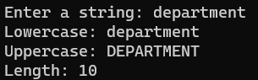

Q10. Write a perl program accept an RNA sequence and display the index number of an entered character

Code:

print("Enter an RNA sequence: ");

$string = <stdin>;

print("Which nucleaotide do you want: ");

$char = <stdin>;

$in_string = index($string, $char);

print($in_string);

Output:

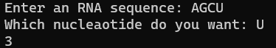

Q11. Write a perl program to match pattern t or u from an entered sequence

Code:  
$seq = <stdin>;

if($seq =~ m/t/ || $seq =~ m/u/){

print("True");

}else{

print("False");

}

Output:







Q12. Write a perl script to split on character “#”

Code:

print("Enter a sentence with '#': ");

$string = <stdin>;

@split_string = split("#", $string);

foreach $n(@split_string){

print("$n\n");

}

Output:

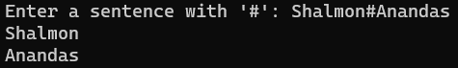

Q13. Write a perl script to split on pattern i.e. whitespaces

Code:

print("Enter a sentence: ");

$string = <stdin>;

@split_string = split(" ", $string);

foreach $n(@split_string){

print("$n\n");

}

Output:

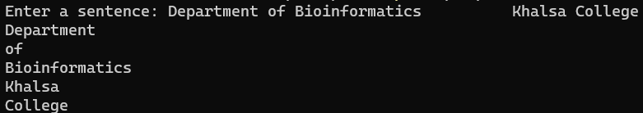

Q14. Write a perl script to split on digit and join using single comma

Code:

print("Enter a sentence: ");

$string = <stdin>;

@string_split = split(/\d/, $string);

print(@string_split);

$string_join = join(",", @string_split);

print($string_join);

Output:

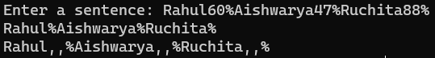

Q15. Write a perl script to demonstrate on splitting on string

Code:

print("Enter a sentence: ");

$string = <stdin>;

@split_string = split(" ", $string);

foreach $n(@split_string){

print("$n\n");

}

Output:

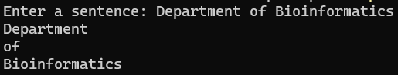

**Practical 8**

**Perl Formatting**

AIM:

Perl uses a writing template called a ‘format’ to output reports. To use the format feature of Perl, you have to define a format first and then you can use the format to write formatted data

format FormatName =

fieldline

value_one, value_two, value_three

fieldline

value_one, value_two

.

Here FormatName represent the name of the format.The fieldline is the specific way, the data should be formatted. The values lines represent the values that will be entered into the field line. You end the format with a single period.

Next field can contain any text or fieldholder. The fieldholders hold space for data that will be placed there at a later date. A fieldholder has the format

@<<<<<<<<<

@>>>>>>>>>

@|||||||||||||||||||||

Q1. Write a perl script to display text at center

Code:  
format CENTER =

=============================================================

@||||||||||||||||||||||||||||||||||||||||||||||||||||||||||||

$string

=============================================================

.

select(STDOUT);

$~ = CENTER;

$string = "Department of Bioinformatics";

write;

Output:

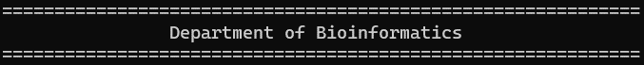

Q2. Write a perlsript to accept a number and display using perl formatter

Code:

format NUMBER =

========

@|||||

$number

========

.

select(STDOUT);

$~ = NUMBER;

$number = <stdin>;

write;

Output:

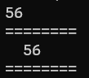

Q3. Write a perl script to accept an array and display the values using perl formatter

Code:

format ARRAY =

===============================

@||||||||||||||||||||||||||||||

$n

===============================

.

select(STDOUT);

$~ = ARRAY;

@array = qw/mondaytuesdaywednesdaythursdayfridaysaturdaysunday/;

foreach $n(@array){

$n;

write;

}

Output:

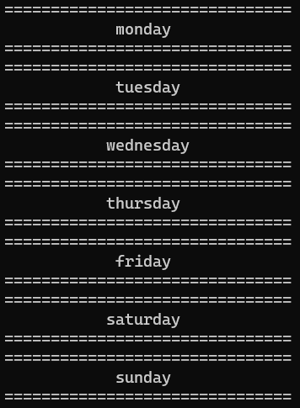

Q4. Write a perl script to accept an array and display only keys using right/center formatting

Code:

format ARRAY =

===============================

@||||||||||||||||||||||||||||||

$n

===============================

.

select(STDOUT);

$~ = ARRAY;

%hash = ("Rohan" => 1, "Aishwarya" => 2, "Aniket" => 3, "Rama" => 4);

foreach $n(keys %hash){

$n;

write;

}

Output:

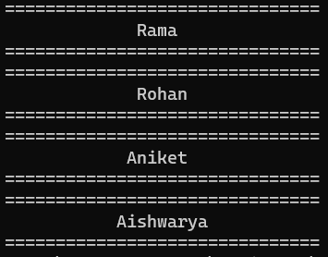

Q5. Write a perl script to accept a decimanl number and display only 4 values adter decimal using formatting

Code:

format DECIMAL =

============

@######.####

$number

============

.

select(STDOUT);

$~ = DECIMAL;

$number = <stdin>;

write;

Output:

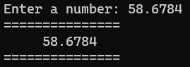

Q6. Write a perl script to display name, age and salary by name employee using formatting

Code:

format EMPLOYEE =

@<<<<<<<<<<<@<<<<<<<<<<<@<<<<<<<<<

$name,$age,$salary

===============================

.

select(STDOUT);

$~ = EMPLOYEE;

@name = qw/Rohan Aishwarya Abhishek Rachael/;

@age = qw/25 27 26 23/;

@salary = qw/60000 43000 28000 54000/;

foreach (@name){

$name = $_;

$age = $age[$i];

$salary = $salary[$i++];

write;

}

Output:

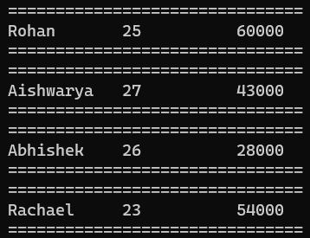

Q7. Write a perl script to diaply name, age and salary by name employee using report formatting

Code:

format EMPLOYEE_TOP =

==============================

Page Number @<

$%

==============================

Name Age Salary

==============================

.

format EMPLOYEE =

@<<<<<<<<<<<@<<<<<<<<<<<@<<<<<<<<<

$name,$age,$salary

===============================

.

select(STDOUT);

$^ = EMPLOYEE_TOP;

$~ = EMPLOYEE;

@name = qw/Rohan Aishwarya Abhishek Rachael/;

@age = qw/25 27 26 23/;

@salary = qw/60000 43000 28000 54000/;

foreach (@name){

$name = $_;

$age = $age[$i];

$salary = $salary[$i++];

write;

}

Output:

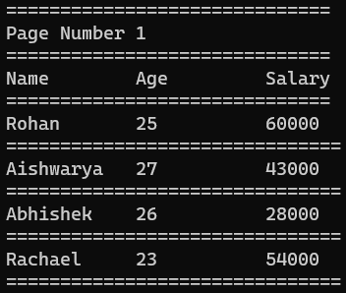

Q8. Write a perl script to display patient_name, patient_age, health_issue and cost_of_treatment of a Patient_Details using formatting

Code:

format PATIENT_TOP =

==============================

Patient Details Page @<

$%

=================================================================

Name Age Health Issue Cost of Treatment

=================================================================

.

format PATIENT =

@<<<<<<<<<<<<<<<@<<<<<<<<<<<@<<<<<<<<<<<<<<<<<<<@<<<<<<<<

$name,$age,$health_issue,$cost_of_treatment

=================================================================

.

select(STDOUT);

$^ = PATIENT_TOP;

$~ = PATIENT;

@name = qw/Sumitra Paresh Vidya Shalmon/;

@age = qw/25 27 26 23/;

@health_issue = qw/Diabetes Covid Scoliosis Cataract/;

@cost_of_treatment = qw/15000 4000 8000 55000/;

foreach (@name){

$name = $_;

$age = $age[$i];

$health_issue = $health_issue[$i];

$cost_of_treatment = $cost_of_treatment[$i++];

write;

}

Output:

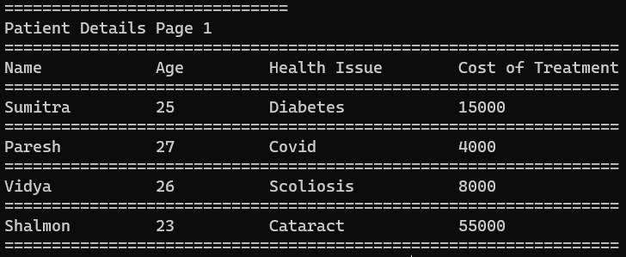

Q9. Write a perl script to diaplysequence_id sequence and alphabet name using report formatting

Code:

format SEQUENCE_DETAILS_TOP =

=================================================================

Sequence Details Page @<

$%

====================================================================================================

SEQ ID SEQUENCE ALPHABET NAME

====================================================================================================

.

format SEQUENCE_DETAILS =

@<<<<<<<<<<<<<<<@<<<<<<<<<<<<<<<<<<<<<<<<<<<<<<<<<<<<<<<<<<<<<<<<<<<<<<<<<<<<<<<<<<<<<<@<<<<<<<<<<

$sequence_id,$sequence,$alphabet_name

====================================================================================================

.

select(STDOUT);

$^ = SEQUENCE_DETAILS_TOP;

$~ = SEQUENCE_DETAILS;

@sequence_id = qw/Q59RL7 Q9ULY5 Q9R0Q8 Q03331/;

@sequence = qw/MSAAKQLFKIVPLTPTEINFLQSLAPVVKEHGVTVTSTMYKYMFQTYPEVRSYFNMTNQK MLSQYDEQLAAGDNNGFNKQGNATLYSFDFVDADDFLDSISGALPNNGHNNVNPNTNDIS MNSTKSPASHHTERGCFKNSQVLSWTIAGASILFLSGCFITRCVVTYRSSQISGQNLQPH MNSSKSSETQCTERGCFSSQMFLWTVAGIPILFLSACFITRCVVTFRIFQTCDEKKFQLP/;

@alphabet_name = qw/FHP_CANNO CPH2_CANAL CLC4E_MOUSE CLC4E_HUMAN/;

foreach (@sequence_id){

$sequence_id = $_;

$sequence = $sequence[$i];

$alphabet_name = $alphabet_name[$i++];

write;

}

Output:

